Vocabulary Cube Activity
Directions: Use your vocabulary words from each short story to complete one cube per short story. You need to do the following to each square: write one of the words, draw a small picture to represent the word, and write a sentence using the word and context clues (definition). We will be making mobiles out of all of the cubes from each short story, so keep them all in your folder!

For example: (juncture- an intersection)
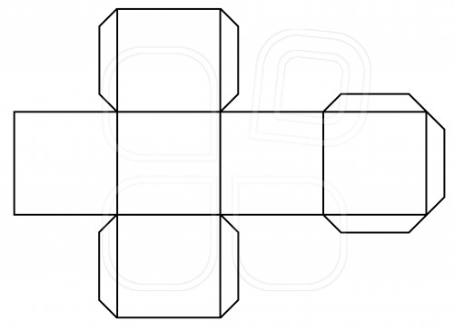
The men walked into the intersection, but could not decide which way to take on the juncture.

